CS 432 Midterm

List users from a given city and state:

Select UserID, UserCity, UserState

FROM user

GROUP BY UserID, UserCity, UserState;

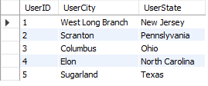

Update users email and/or password given the userID:

Select UserID, UserEmail, UserPassword

FROM usercredentials

Group by UserID, UserEmail, UserPassword;

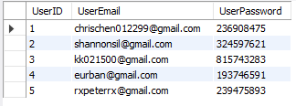

Users who logged in a given month:

Select UserID as LoggedInOct from usercredentials where month(LastLoginDate) = 10

and year(LastLoginDate) = 2020;



Count of each users photos posted:

Select UserName, count(PhotoID) NoOfPhotos

FROM user inner join photos

ON user.UserID = photos.UserID

GROUP BY UserName;

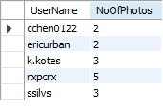

Top 10 photos with most likes:

Select PhotoID, LikeCount

FROM photos

order by LikeCount desc

limit 10;

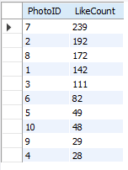

Top 10 photos with most dislikes:

Select PhotoID, DislikeCount

FROM photos

order by DislikeCount desc

limit 10;

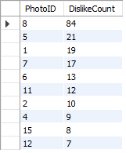

A count of photos by tagged categories

Select CategoryName, count(CategoryName) NumOfPhotos

From photocategories

Group by CategoryName;

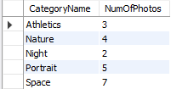

List Users who have posted sports related photos

Select UserName , count(CategoryName) as SportPhotos

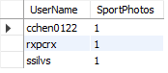from user inner join photos

on photos.UserID = user.UserID

inner join photocategories on photocategories.PhotoID = photos.PhotoID

where photocategories.CategoryName = 'Athletics'

group by UserName;

Top 5 users with most comments:

Select UserName , count(CommentID) as NumOfComments

from user inner join photocomments

on photocomments.UserID = user.UserID

group by UserName

order by NumOfComments desc

limit 5;

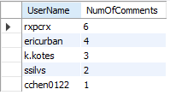

Top 5 Most Popular Categories:

Select CategoryName, count(CategoryName) NumOfPhotos

From photocategories

Group by CategoryName

order by CategoryName desc;

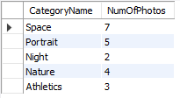

Top 10 Comments with the most likes:

Select CommentID, CommentText, CommentLikes

FROM photocomments

order by CommentLikes desc

limit 10;

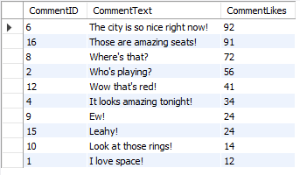

Which users have logged in most recently:

Select UserID, LastLoginDate

FROM usercredentials

order by LastLoginDate desc;

